Number | Name of Achievement | Rule | Stamp Image
1 | First stamp (visited 1 country) | User visits 1 unique country | 
11 | 3 countries explored | User visits 3 unique country | 
13 | 5 countries explored | User visits 5 unique country | 
15 | 10 countries explored | User visits 10 unique country | 
26 | 20 countries explored | User visits 20 unique country | 
20 | 3 continents explored | User visits 3 unique continents | 
30 | 5 continents explored | User visits 5 unique country | 
32 | Global explorer (6+ continents) | User visits 6+ unique country | 
2 | First restaurant logged | User visits 1 restaurant | 
12 | 10 restaurants visited | User visits 10 restaurants | 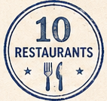
14 | 25 restaurants visited | User visits 25 restaurants | 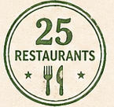
16 | 50 restaurants visited | User visits 50 restaurants | 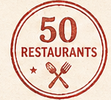
27 | 100 restaurants visited | User visits 100 restaurants | 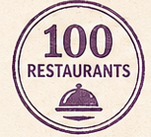
29 | 250 restaurants visited | User visits 250 restaurants | 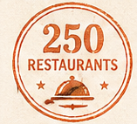
31 | 500 restaurants visited | User visits 500 restaurants | 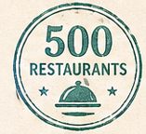
3 | Street food master – Mexico City | User visits restaurant in Mexico city | 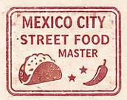
4 | Sushi pilgrim – Tokyo | User visits restaurant in Tokyo | 
5 | Fine dining connoisseur – Paris | User visits restaurant in Paris | 
6 | Pasta purist – Rome | User visits restaurant in Rome | 
7 | Tapas crawler – Barcelona | User visits restaurant in Barcelon | 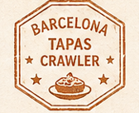
8 | BBQ explorer – Austin | User visits restaurant in Austin | 
9 | Night market hunter – Bangkok | User visits restaurant in banco | 
10 | Dim sum devotee – Hong Kong | User visits restaurant in Hong Kong | 
17 | Vegetarian explorer (10 veg meals logged) | User visits 10 restaurants that have a vegetarian tag | 
18 | Michelin hunter (visited 1 Michelin recommended restaurant) | user visits 10 restaurant that has a source listed as "https://guide.michelin.com" | 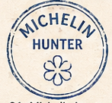
19 | 3 Michelin restaurants visited | user visits 3 restaurant that has a source listed as "https://guide.michelin.com" | 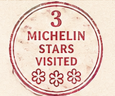
28 | Tasting menu experience (completed 3 tasting menus) | user adds saves a dish labeled "tasting menu" | 
21 | Wine pairing pro (5 wine-paired meals) | user goes to 5 restaurants that have wine listed as the drink pairing | 
22 | Late night eater | User visits 5 restaurants with hours listed as late night | 
23 | Street food lover | User visits 5 restaurants with street food tag | 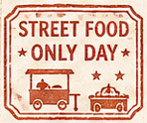
24 | Local favorite (visited 5 non-touristy spots) | User visits 5 restaurants with local favorite tag | 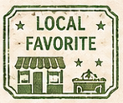
25 | “Passport streak” (logged meals 7 days in a row) | User logs 7 days of meals in a row | 

